**Project Name:** ChatBot Application

**Github Link:** https://github.com/projectsforstudents2022/ChatBot_Application.git

**Why was this project created?**

An automated computer called a chatbot (conversational AI) replicates human conversation using text messaging, voice conversations, or both. Using a variety of inputs, Natural Language Processing, it learns to accomplish that (NLP). These days, businesses want to grow their operations, and since chatbots are not restricted by space or time, they make an excellent tool for this.

**What problem is it solving?**

Chatbots increase operational effectiveness and save costs for organizations while providing convenience and extra services to both internal staff and external clients. They lessen the need for human engagement while enabling businesses to quickly address a wide range of client inquiries and difficulties. A key distinction for businesses is the ability to grow, customize, and be proactive all at once with chatbots. Chatbots, on the other hand, enable businesses to interact personally with an endless number of consumers and may be scaled up or down in response to demand and organizational requirements. A company may simultaneously provide millions of customers proactive, human-like support by deploying chatbots.

**Entire explanation of project**

* **PROPOSED APPROACH**

Installing various packages is the first step in creating a chatbot using Python and machine learning. Next, establish a few basic intents, a set of messages that fit those intents, and map some answers depending on each intent category. Preparing the data to train our chatbot is the second phase in our quest to construct a chatbot using Python and machine learning. Now, in order to develop a chatbot with Python and Machine Learning, we must vectorize the data using the tokenization approach. The training of a neural network is the next and most crucial phase in the process of creating a chatbot with Python and machine learning. I will now construct a neural network and train it to teach our chatbot.

After training the model, let's save it so that we may utilise the neural network in the future. Otherwise, we won't be able to create a chatbot with Python and machine learning. I'm going to add a chat feature right now so that I can converse with actual users. The chatbot will calculate the degree of similarity between the fresh text's sequence and the training data when it receives the user's message. It classifies the user's message in accordance with the aim with the highest trust score after taking into consideration the trust ratings attained for each category.

Algorithm for creating next word prediction model :

**Step 1:** Defining the Intentions

**Step 2:** Data preparation

**Step 3:** Tokenization

**Step 4:** Training a Neural Network

**Step 5:** Build Chatbot

**Step 6:** Testing

* **DATA FLOW DIAGRAM**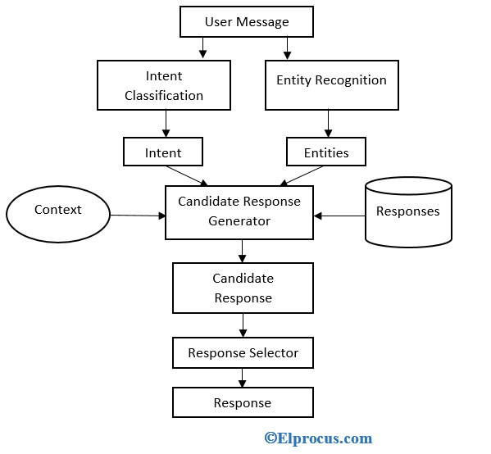
* **RESULT**

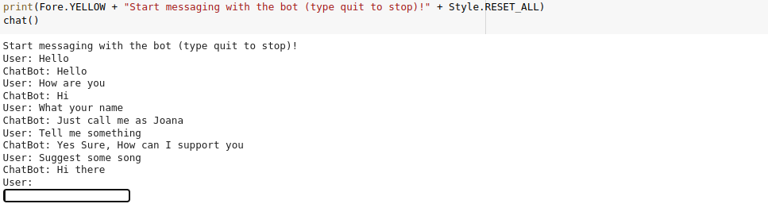

* **CONCLUSION**

A chatbot, on the other hand, is one option that is guaranteed to please the modern client. Your business can quickly provide excellent service and handle disputes for a big number of consumers at once with the help of a chatbot. 90% of consumers, according to Microsoft, anticipate that customer assistance will be available online. The need for AI-powered chatbots will only increase as they become an increasingly important part of corporate progress.